Appendix 1: Primary Care Information

Faecal Immunochemical Test (FIT): Information for Secondary Care Clinicians
This document contains guidance for the implementation of the Faecal Immunochemical Test (FIT) in secondary care.
As a secondary care clinician you will be vetting referrals from primary care where a patient has undertaken a FIT or you might be using FIT in your Health Board as a COVID mitigation strategy to assist with prioritisation of patients with NG12/suspected cancer symptoms. This guidance is intended to assist you in both situations.
What is FIT?
FIT is a type of faecal immunochemical blood test used to detect traces of blood in stool samples. The test uses antibodies that specifically recognise human haemoglobin and therefore it is a more sensitive and specific test than the guaiac based FOB test. It also measures the faecal Hb concentration (f-Hb) as microgram of Hb per gram (μg/g) of faeces.
NICE Guidance DG30 (July 2017) states: “Faecal Immunochemical Tests (FIT) are recommended for adoption in primary care to guide referral for suspected colorectal cancer in people without rectal bleeding who have unexplained symptoms but do not meet the criteria for a suspected cancer pathway referral.”
FIT is currently being used with patients that present with NG12 (suspected cancer) symptoms in many Health Boards as part of their COVID mitigation strategy. This guidance therefore recommends that if used for prioritisation in this group within secondary care for patients that present with NG12 (suspected cancer) symptoms, a FIT is requested at the same time as referring the patient to secondary care.
Who will be offered a FIT test in primary care?
NICE DG30 (lower risk symptoms): A FIT will be offered prior to considering referral for any patient with abdominal symptoms but without rectal bleeding who doesn’t fit the NG12 guidance on suspected cancer.
NICE NG12 (suspected cancer symptoms): A FIT may be offered to any patient that presents with suspected cancer symptoms at the same time as referring the patient to secondary care.
Using FIT in secondary care
If a FIT has not been requested in primary care, it can be requested from secondary care as a COVID mitigation strategy to assist with prioritisation of patients referred in via the NG12/suspected cancer symptom route. This use of FIT should be recorded and patient outcomes captured in order to facilitate future audit and evaluation.
Benefits of FIT
- Possible reduction in unnecessary invasive procedures.
- FIT specifically measures human haemoglobin (Hb) rather than any other blood in the diet.
- FIT is a quality assured test as the analysers that carry out the testing are fully automated.
- A numerical figure result is provided which can help to inform future management of patients.
Clinical Pathway
Please see Figure 1 for the national FIT pathway for both primary and secondary care.
Ordering a testing kit
- When can we start using the test?
  - FITs will be available to request from …. Please insert date dependent on availability within HB
- How do we order a FIT?
- You will make an online request which will be processed by the laboratory. The FIT kits will be sent to the patient from the laboratory in a pack that contains patient information and instructions and the patient will return their sample directly back to the laboratory.
Pathology Process
Different laboratories follow different processes. Please see Figures 2 and 3 for the process from the Bowel Screening Wales/Cwm Taf Morgannwg laboratory pathway. Please refer to the process appropriate to your Health Board.
Safety Netting
Whilst FIT is a very sensitive test, even at a level of < 10 mcg/g there will be false negative results and cases of colorectal cancer (CRC) (sometimes in the presence of iron deficiency anaemia (IDA) or abdominal pain), therefore safety netting is essential and FIT should always be used as part of comprehensive assessment.
a negative FIT result either in the absence of suspected cancer features such as IDA, a palpable abdominal or rectal mass or strong clinical suspicion, can exclude CRC (though not necessarily pre-cancerous polyps to the same extent) in the vast majority of cases and the patient is unlikely to require an onward referral. Studies have predominately been secondary care based, however two recent and relevant studies to our framework include a primary care study from Oxford and one that is a large primary and secondary care based study from London both published very recently. This clearly demonstrates our approach as being evidence based and practically feasible with adequate safety netting within the national FIT pathways proposed.
As previously mentioned it is essential to note that not all patients with CRC will have a positive FIT result, and some patients’ symptoms might also be an indication of another type of cancer that will require onward referral and/or investigation. Equally if a patient has a positive FIT but a negative endoscopy, they may require further investigation to rule out another type of cancer.
Tracking of tests issued to patients but not completed
Please refer to the process appropriate to your Health Board:
- Cwm Taf Morgannwg laboratory: If the patient does not return the test to the laboratory within 1 week, the laboratory will flag this up with the referring clinician who should then contact the patient to discuss if the sample has been sent.
- Bowel Screening Wales laboratory: The laboratory will alert local coordinators based in Health Boards if the sample has not been received within 14 days.
Results
- How soon can results be expected?
The results should be available within 1 week of the patient sending in the sample.

- Where can the results be accessed?
The results can be accessed on Welsh Clinical Portal.

- What do I need to do with the results?
Please refer to the national FIT clinical pathway (Figure 1) to assist with your decision making
What if a patient has recently completed their Bowel Cancer Screening?
Irrespectively of how recently your patient was screened by the national Bowel Cancer Screening programme, their new FIT result should NOT be ignored in considering a patient presenting with new symptoms of concern which should be considered on their own merit.
In symptomatic patients FIT is used as a ‘rule out’ tests and the test is made as sensitive as possible (>10 µg Hb/gram faeces) in order that the chance of missing cancer is minimised. In screening the test is used as a ‘rule in’ test and the test is much less sensitive (>150 µg Hb/gram faeces currently) in order to not overwhelm colonoscopy capacity. A negative screening FIT is therefore very different from a negative symptomatic FIT. If your patient has symptoms, don’t be falsely reassured by a negative screening FIT result as pathology could still be present.
Where can I access further information and support?
Insert contact details of Health Board team

FIGURE 1 – NATIONAL FIT PATHWAYS

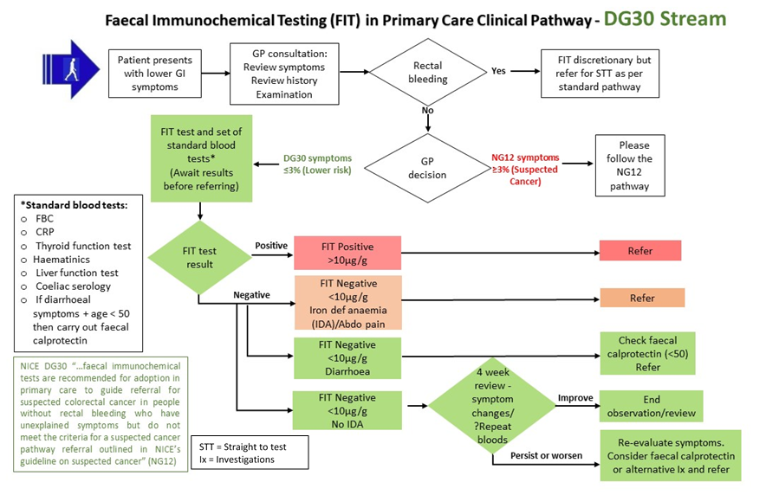

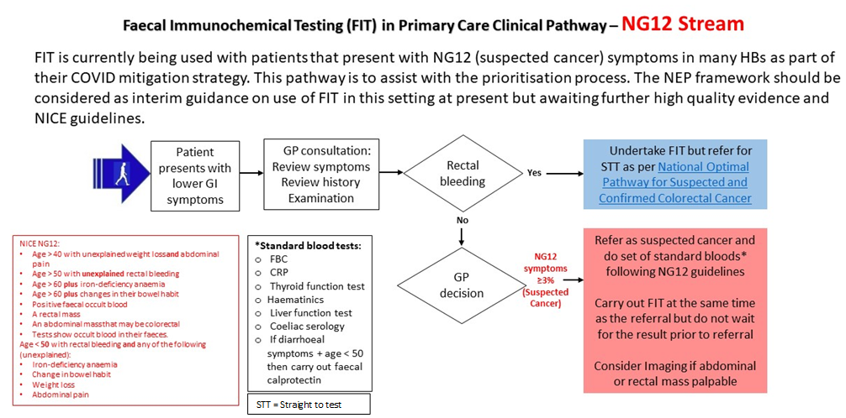

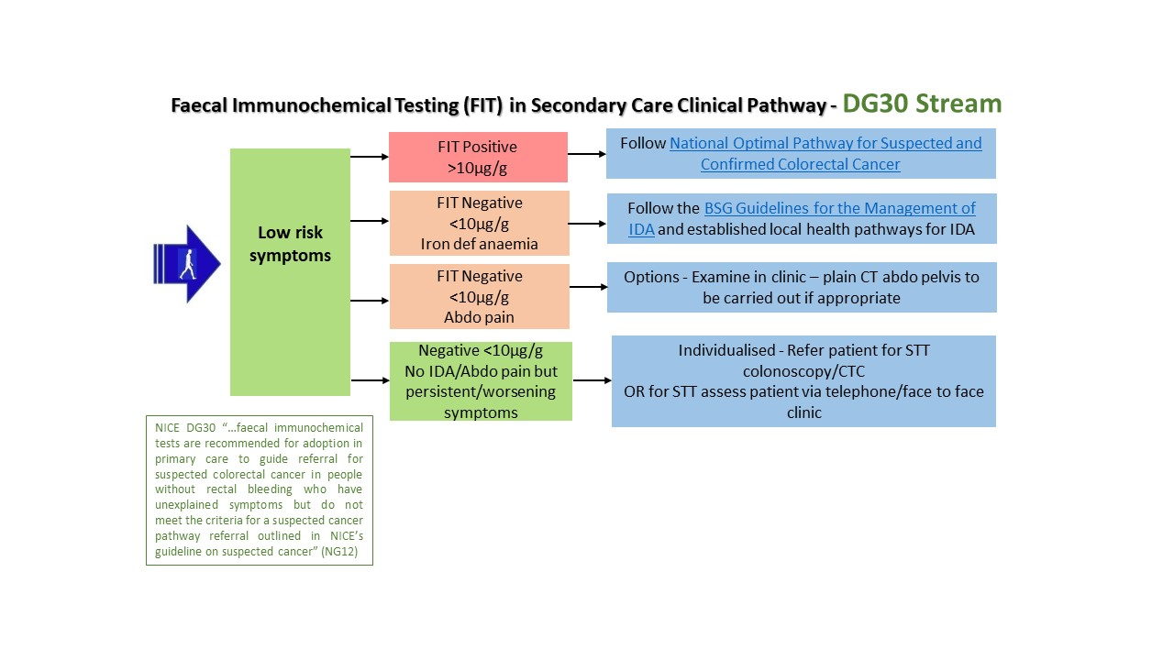
STT = Straight to test

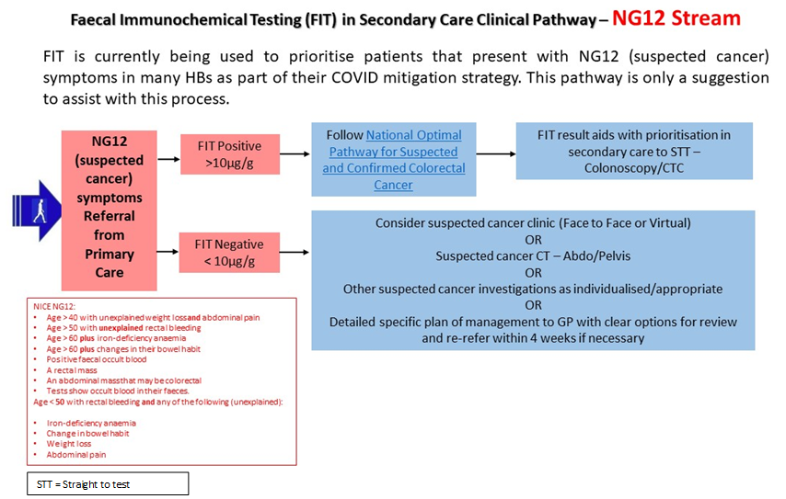

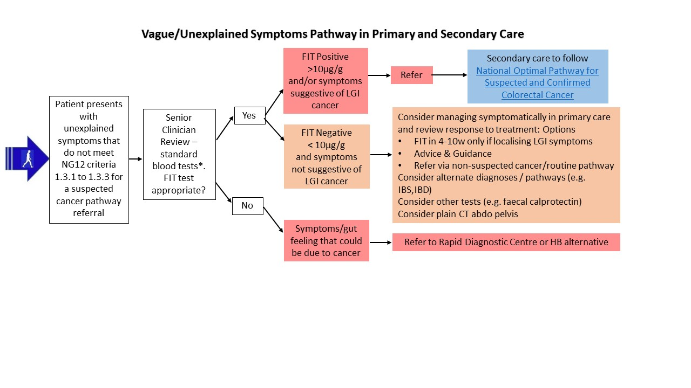
Vague/Non-Specific Symptoms Pathway in Primary and Secondary Care

FIGURE 2 – CWM TAF MORGANNWG LABORATORY PATHOLOGY PATHWAY
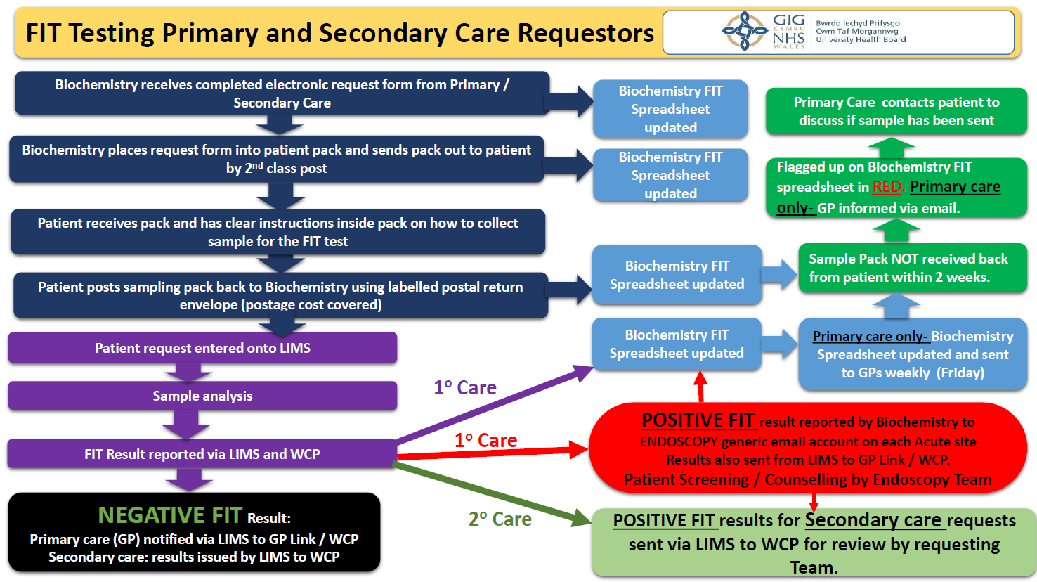

FIGURE 3 – BOWEL SCREENING WALES LABORATORY PATHOLOGY PATHWAY

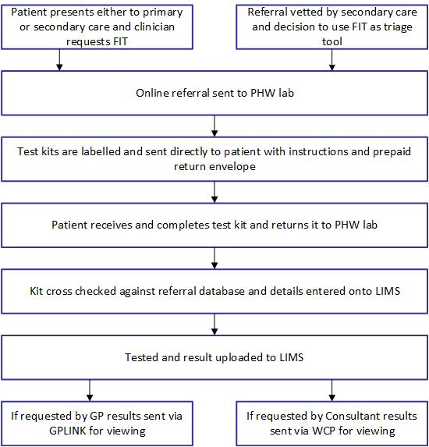

Nicholson B et al Aliment Pharmacol Ther. 2020;52:1031–1041.
Loveday C, et al. Gut 2020;0:1–8. doi:10.1136/gutjnl-2020-321650

